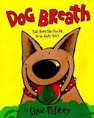
Recognize and Explain
Cause and Effect Relationships
Name: ________________ Date: _______________
Effect: What Happened

Effect: What Happened

horrible things happened
Cause: Why Did It Happen
Effect: What Happened

Tosis family decided to keep Hally Tosis.
Effect: What Happened

Cause: Why Did It Happen
Cause: Why Did It Happen
“Come here, poochie poochie!” whispered the other burglar.

Hally had smelly breath.
Cause: Why Did It Happen

